AML/BSA Compliance Program

MAL MONEY INC. (Trade Name: Mal Money)
BaaS Program Manager - Anti-Money Laundering and Counter-Terrorism Financing
EIN: 16878389 | Montana Corporation | 821 N 27th St #2066, Billings, MT 59101-1121, USA

DOCUMENT CONTROL
Ver. | Effective Date | Prepared By | Summary | Approved By
1.0 | March 31, 2026 | AML/BSA CO | Initial version adopted by Board of Directors. To be read together with the Governance, Regulatory Perimeter and Compliance Positioning Memorandum. | Board of Directors

This AML/BSA Compliance Program is approved by the Board of Directors of MAL MONEY INC. (the "Company"), and is reviewed at least annually or upon any material regulatory, operational, or structural change.
This Program must be read together with the Governance, Regulatory Perimeter and Compliance Positioning Memorandum, which contains the foundational legal analysis on which all representations in this Program are conditional.

GLOSSARY OF KEY TERMS
Term | Definition
AML / BSA | Anti-Money Laundering / Bank Secrecy Act. Primary U.S. federal AML framework administered by FinCEN under 31 U.S.C. § 5311 et seq. The BSA requires covered financial institutions to establish internal controls, designate a compliance officer, conduct training, and undergo independent testing as the four core pillars of a compliant AML program.
BaaS | Banking-as-a-Service. Arrangement in which a non-bank company provides financial products and services using the infrastructure, licenses, and rails of one or more regulated depository institutions. In a BaaS model, regulatory account-holding responsibilities reside with the Banking Partner, while the BaaS Program Manager typically governs compliance design and monitoring.
Beneficial Owner | A natural person who ultimately owns or controls a legal entity. Under 31 C.F.R. § 1010.230: (i) Ownership prong - any individual owning 25% or more of a legal entity customer; and (ii) Control prong - a single individual with significant responsibility to control, manage, or direct the entity (e.g., CEO, CFO, COO, Managing Member). Both prongs apply independently. The Company applies an enhanced 10% threshold for Tier 3 EDD as an internal standard more stringent than the regulatory minimum.
CO / Compliance Officer | Individual appointed to oversee the AML/BSA compliance framework, with responsibilities and authority as defined by the Company's governance documents and applied in accordance with the confirmed regulatory perimeter. Where the Company is determined to be an MSB under the confirmed perimeter analysis, this role is required per 31 C.F.R. § 1022.210. The CO maintains direct reporting access to the Board of Directors, independent of revenue management.
CTR | Currency Transaction Report. Filed with FinCEN for cash transactions exceeding $10,000 in a single business day per 31 C.F.R. § 1010.311. Filing responsibility in the Company's BaaS model is confirmed in the companion Governance and Legal Positioning Memorandum.
CVC | Convertible Virtual Currency. A digital representation of value that has an equivalent value in real currency or acts as a substitute for real currency, as defined in FinCEN's 2013 and 2019 guidance.
CDD / EDD | Customer Due Diligence / Enhanced Due Diligence. Risk-based processes for verifying customer identity and assessing the risk profile of a customer relationship. EDD applies heightened scrutiny, including source of funds and source of wealth analysis, to higher-risk customer relationships.
Enhanced Sanctions and Illicit Finance Screening | The Company's screening program covering, in addition to primary OFAC SDN screening: SDGT (counterterrorism); SDNTK (narcotics); NPWMD (non-proliferation); E.O. 13224 and E.O. 13268; UN Security Council Consolidated List. This term is used throughout this Program in preference to 'secondary sanctions screening', which has a distinct technical meaning relating to exposure consequences for non-U.S. persons.
FATF | Financial Action Task Force. Intergovernmental body that sets international AML/CTF standards. Its recommendations inform the Company's internal risk assessments but are not binding U.S. law. FATF public list status (grey list/black list) is one input among multiple risk factors in the Company's internal corridor risk classification and is not the operative trigger for the Company's enhanced controls.
FinCEN | Financial Crimes Enforcement Network. A bureau of the U.S. Department of the Treasury that administers the BSA, issues guidance and advisories, and receives SAR, CTR, and other BSA filings.
MSB | Money Services Business. A category defined under 31 C.F.R. § 1010.100(ff), to the extent confirmed by the Company's regulatory perimeter analysis. If the Company is determined to be an MSB, registration obligations arise under 31 C.F.R. § 1022.380 and AML program requirements arise under 31 C.F.R. § 1022.210. The Company's MSB determination is a gating condition addressed in the companion Governance and Legal Positioning Memorandum.
OFAC | Office of Foreign Assets Control. U.S. Treasury bureau that administers and enforces economic and trade sanctions programs. OFAC compliance is a standalone obligation distinct from BSA/AML reporting.
PEP | Politically Exposed Person. An individual who holds or has held a prominent public function, presenting a higher risk of involvement in bribery or corruption. PEP relationships require enhanced due diligence and senior management approval.
SAR | Suspicious Activity Report. Filed with FinCEN where a financial institution knows, suspects, or has reason to suspect criminal activity involving $2,000 or more (for MSBs) per 31 C.F.R. § 1022.320. The filing institution for SARs in the Company's BaaS model is confirmed in the Governance and Legal Positioning Memorandum. SAR information is strictly confidential per 31 U.S.C. § 5318(g)(2).
SDN | Specially Designated National. An individual or entity listed on OFAC's SDN List with whom U.S. persons are generally prohibited from transacting.
Travel Rule | The applicable U.S. recordkeeping and information transmission requirements for transmittals of funds at or above $3,000 per 31 C.F.R. § 1010.410, and equivalent information-sharing expectations applied to digital asset activity within the Company's confirmed operating model per FATF Recommendation 16. Direct applicability depends on the confirmed regulatory perimeter and the structure of virtual asset transaction flows.
VASP | Virtual Asset Service Provider. An entity that conducts virtual asset activities as a business, regulated under FATF Recommendation 16 and applicable national frameworks. VASPs used by the Company as off-ramp partners are required to be compliant with their applicable local regulatory obligations.
ARBP | Annual Report of Blocked Property. Filed with OFAC by September 30 for property held as blocked as of June 30 of the same year, per 31 C.F.R. § 501.603. Applicability depends on whether the Company holds blocked property and is the responsible reporting party under the confirmed filing allocation.

Table of Contents
GLOSSARY OF KEY TERMS 3
1. Document Purpose and Perimeter Reference 7
2. Standards Hierarchy 7
3. Business Model - Partner-Neutral BaaS Structure 8
4. Regulatory Perimeter and Filing Allocation 10
4.1 Filing Allocation Principle 10
4.2 314(a) / 314(b) Information Sharing 10
5. Governance and Three Lines of Defense 11
5.1 Board Oversight 12
5.2 U.S. AML/BSA Compliance Officer 12
5.3 Three Lines of Defense 12
6. Enterprise Risk Assessment - Risk-to-Control Linkage 14
7. Corridor Risk Classification Framework 14
8. Customer Risk Management 15
8.1 Beneficial Ownership 15
9. Transaction Monitoring and SAR Governance 17
9.1 Monitoring Coverage 17
9.2 Alert Severity Model 19
9.3 KYC/CDD Tier Assignment 20
9.4 Pakistan Province Sub-Risk Classification 21
9.5 Enhanced Sanctions and Illicit Finance Screening 22
9.6 SAR Committee and Quality Assurance 22
10. Sanctions Compliance 22
11. Independent Testing Commitment 22
12. Exceptions and Issues Management 23
13. Board Compliance Dashboard and Metrics 23
14. Change Management and Vendor Oversight 25
15. Training 25
16. Recordkeeping and Version Control 25
Customer and Identity Risk 28
Transaction Monitoring and Sanctions Risk 29
A3.1 Risk-Tiered Onboarding Framework 30
A3.2 Corridor Risk Classification 31
A3.3 Pakistan Province-Level Sub-Risk 31
A3.4 Beneficial Ownership 32
A3.5 Prohibited Customer Types 32
A4.1 Alert Severity Model 33
A4.2 SAR Filing and Escalation 33
A4.3 ACH Return and Recall Fraud Controls 34
A4.4 Stablecoin and CVC Monitoring 34
Annual Compliance Deadlines - Quick Reference 37
Active Issues Register 39
Section 1 - Case Identification 40
Section 2 - CO Review and Disposition 41
Training Delivery Requirements 42
Attendee Sign-In 44
Part A - Corridor Identification and Source Log 46
Part B - Risk Summary 47
Part C - Go-Live Checklist 47

1. Document Purpose and Perimeter Reference
This AML/BSA Compliance Program establishes the board-approved framework by which MAL MONEY INC. (the Company) prevents, detects, and escalates potential money laundering, terrorist financing, sanctions evasion, and related financial crime risks. It is designed to meet the governance expectations of U.S. banking partners, FinCEN, and OFAC, including the interagency third-party risk management lifecycle described in the 2023 Interagency Guidance on Third-Party Relationships: Risk Management.
This Program is constructed as a partner-neutral compliance framework - meaning that its structure and content are designed to remain operationally valid regardless of the specific Banking Partner engaged in any given corridor. Where operational details are Banking Partner-specific, they are governed by the relevant Corridor Addendum (Annex 10) or by the contractual arrangements with the relevant partner, rather than the policy body itself.
This Program should be read as the governing policy document within a three-part compliance package: (i) this Program, which establishes the AML/BSA architecture and governance framework; (ii) the Governance, Regulatory Perimeter and Compliance Positioning Memorandum, which contains the foundational legal determinations on which all conditional representations in this Program are based; and (iii) the Annexes and Logbooks Pack, which constitute the operational procedures and evidence layer. Reading this Program in isolation from the companion Memorandum is not sufficient.

2. Standards Hierarchy
The following standards hierarchy identifies which regulatory sources govern the Company's AML/BSA framework, how those sources interact, and where their applicability depends on the confirmed regulatory perimeter. Standards cited in this hierarchy that are contingent on MSB classification or filing institution designation are incorporated on a conditional basis, as indicated, and their applicability is governed by the companion Governance and Legal Positioning Memorandum.

# | Standard / Source | Application
1 | BSA / 31 C.F.R. § 1022.210 (MSB AML program four pillars) | Internal controls, CO, training, independent review - applicable to the extent Company is an MSB per Governance and Legal Positioning Memo
2 | 31 C.F.R. § 1022.320 (SAR); 1010.311 (CTR); 1010.410 (Travel Rule) | Reporting thresholds and deadlines; filing institution allocation per companion Governance Memo
3 | OFAC Sanctions Compliance Framework (five components) | Management commitment, risk assessment, internal controls, testing, training - all corridors
4 | FATF Recommendations - risk-based approach, CDD, STR, Rec. 16 | Global baseline; FATF list status is ONE input in internal risk classification, not the operative trigger
5 | Interagency Third-Party Risk Guidance (OCC/FDIC/FRB, 2023); FDIC FIL-29-2023 | BaaS program manager vendor and partner oversight lifecycle: planning, due diligence, contracting, ongoing monitoring, termination
6 | FinCEN advisories and notices - rolling 30-day incorporation | Typologies updated within 30 days of each new FinCEN advisory; see Annex 4 (TM Procedures)

3. Business Model - Partner-Neutral BaaS Structure
MAL MONEY INC. functions as a technology-enabled compliance infrastructure layer within the BaaS value chain. Its role is to design, operate, and maintain an AML/BSA compliance program that governs customer onboarding, ongoing due diligence, transaction monitoring, regulatory escalation, and recordkeeping - on behalf of itself and in coordination with its Banking Partners.
The Company is not a deposit-taking institution. It does not hold customer funds in its own name and does not control the banking accounts through which customer transactions ultimately settle. The regulatory accounts - and the attendant account-level AML obligations - reside with the Banking Partner, which is a regulated depository institution subject to its own independent AML program requirements.
This structural distinction has direct consequences for filing allocation. Where the Company is the confirmed regulated filing institution - as will be determined by the companion Governance and Legal Positioning Memorandum - it accepts full responsibility for SAR filing, CTR filing, and OFAC reporting within applicable deadlines. Where the Banking Partner is the confirmed filing institution, the Company performs the detection and investigation function and delivers a complete, professionally prepared escalation package in time to support the Partner's own filing deadline.
The Company does not engage in proprietary trading, does not offer investment products, and does not serve as a custodian of digital assets for client investment purposes. Its operations are exclusively payments infrastructure, compliance governance, and BaaS program management for institutional clients - licensed financial institutions, fintech companies, money transfer operators, and remittance providers.
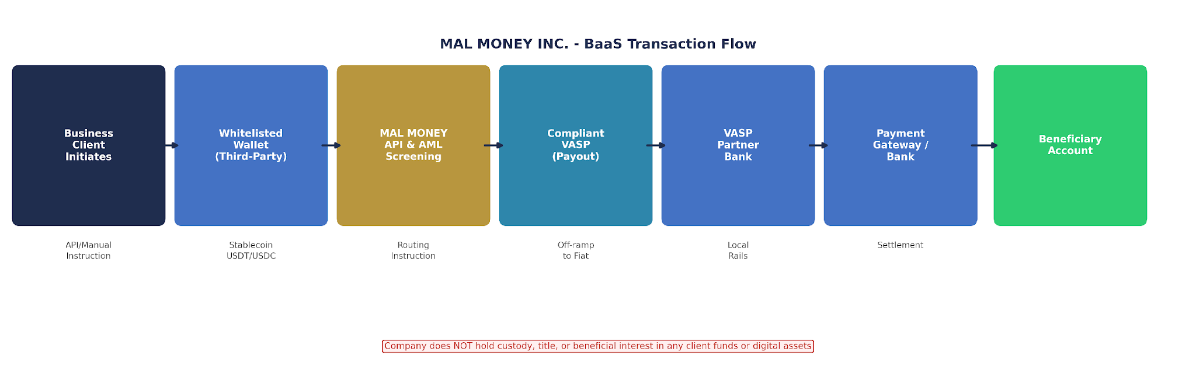
Figure 1 - BaaS Transaction Flow. The Company acts as the API, AML screening, and compliance layer. The Banking Partner holds regulated accounts. The Company does NOT hold custody, title, or beneficial interest in any client funds or digital assets.

Role | Category | AML/BSA Responsibility
Banking Partner(s) | Regulated depository institution | Holds accounts; provides rails; primary filing institution for SAR/CTR where applicable per Governance and Legal Positioning Memo
Infrastructure Providers | IDV, TMS, card, fraud tooling | Technology; subject to Company vendor oversight lifecycle per 2023 interagency guidance
The Company | BaaS Program Manager | Operationalizes controls, investigations, documentation; files directly where confirmed filing institution; escalates to Partner where not

4. Regulatory Perimeter and Filing Allocation
The filing allocation framework is one of the most structurally significant features of this Program, and its content is deliberately conditional on the legal and operational determinations set out in the companion Governance, Regulatory Perimeter and Compliance Positioning Memorandum.
Whether the Company files regulatory reports directly as a regulated MSB, acts as a compliance intermediary supporting a Banking Partner's filing obligations, or operates under a hybrid model depends on: (i) the confirmed characterization of the Company's activities under applicable FinCEN definitions; (ii) the contractual allocation of filing responsibilities between the Company and its Banking Partners; and (iii) the legal analysis of any applicable agent-of-a-financial-institution exception or equivalent mechanism.
This Program adopts a two-path escalation model that remains operationally valid regardless of which path is confirmed as applicable. Under both paths, the Company maintains full investigation quality standards, complete recordkeeping, and timely action. The only variable is the identity of the filing institution - and that determination is made by the companion legal memorandum, not by this Program's unilateral representation.

4.1 Filing Allocation Principle
- Path A - Company is Filing Institution: Files SARs within 30 days at $2,000 threshold per 31 C.F.R. § 1022.320; CTRs within 15 calendar days per 31 C.F.R. § 1010.311. Accepts full regulatory filing responsibility.
- Path B - Banking Partner is Filing Institution: Company detects, investigates, and prepares a complete escalation package transmitted to the Banking Partner within ~20 days of initial detection, supporting the Partner's 30-day SAR deadline. Company logs all escalations, tracks transmission, and monitors outcomes.
- In all cases, investigation quality standards, recordkeeping obligations, and response SLAs are identical regardless of the filing path applicable.

4.2 314(a) / 314(b) Information Sharing
- 314(a): CO designated as FinCEN contact. Records searched within ~2 weeks of request. All requests strictly confidential per federal law.
- 314(b): Voluntary information-sharing framework established. Active participation requires prior FinCEN notice of intent, counterparty eligibility verification, and limitation to suspected ML/TF. Confirmed only upon FinCEN notice filing.

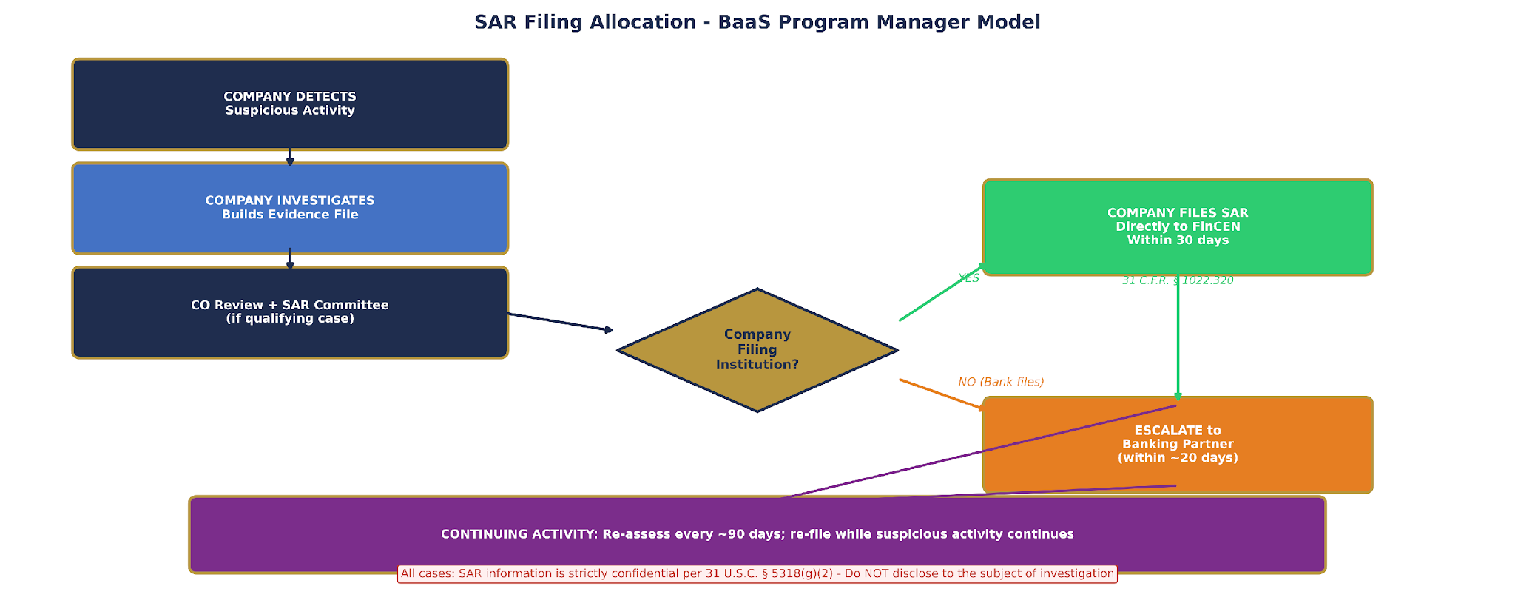
Figure 2 - SAR Filing Allocation. Under Path A (right, green), the Company files the SAR directly with FinCEN within 30 days. Under Path B (left, orange), the Company prepares an escalation package for the Banking Partner within ~20 days. The applicable path is confirmed in the Governance and Legal Positioning Memorandum.

5. Governance and Three Lines of Defense
The governance structure described in this Section is not ceremonial. It reflects a substantive regulatory principle: AML/BSA compliance cannot be managed as a subordinate function within a business line. It must be structurally independent, adequately resourced, and operationally accountable to the highest level of the organization.
The requirement for direct Board reporting by the U.S. AML/BSA Compliance Officer is designed to ensure that compliance findings, program gaps, escalation decisions, and resource needs reach the Board without being filtered, delayed, or deprioritized by revenue-generating management. Regulatory guidance and enforcement history are both clear that management-layer intermediation - however administratively efficient it may appear - undermines the independence that an effective AML program requires.

5.1 Board Oversight
The Board approves this Program and all material revisions. It receives quarterly compliance dashboards and an annual Program Effectiveness Report. The Board approves the annual compliance budget, commissions the independent AML audit, and approves go-live of High or Very High Risk corridors. Board oversight is not delegable to a committee or management-level body on matters of program approval, audit commissioning, or High Risk corridor authorization.

5.2 U.S. AML/BSA Compliance Officer
The CO is U.S.-based, reflects the Company's primary legal obligations under U.S. federal law, and maintains compliance oversight proximate to those obligations. The CO reports directly and independently to the Board. No management intermediary may filter or restrict CO communications with the Board. CO compensation is not tied to revenue, profit, or customer acquisition metrics. CO removal requires a formal Board resolution.
Local compliance coordination functions in high-risk jurisdictions - such as the Head of Compliance in Pakistan - support first-line operational consistency in the Company's highest-risk corridor. They do not substitute for or replace the second-line independence of the U.S. AML/BSA Compliance Officer, whose authority extends to all corridors and all compliance functions.

5.3 Three Lines of Defense
- First Line: operational staff execute controls daily - onboarding, payments, fraud monitoring, customer support.
- Second Line: CO and Compliance Department design controls, oversee first line, conduct investigations, maintain reporting governance. Reports directly to Board.
- Third Line: independent audit function or qualified external independent reviewer tests program effectiveness; reports directly to Board. The CO is explicitly excluded from the independent testing function.
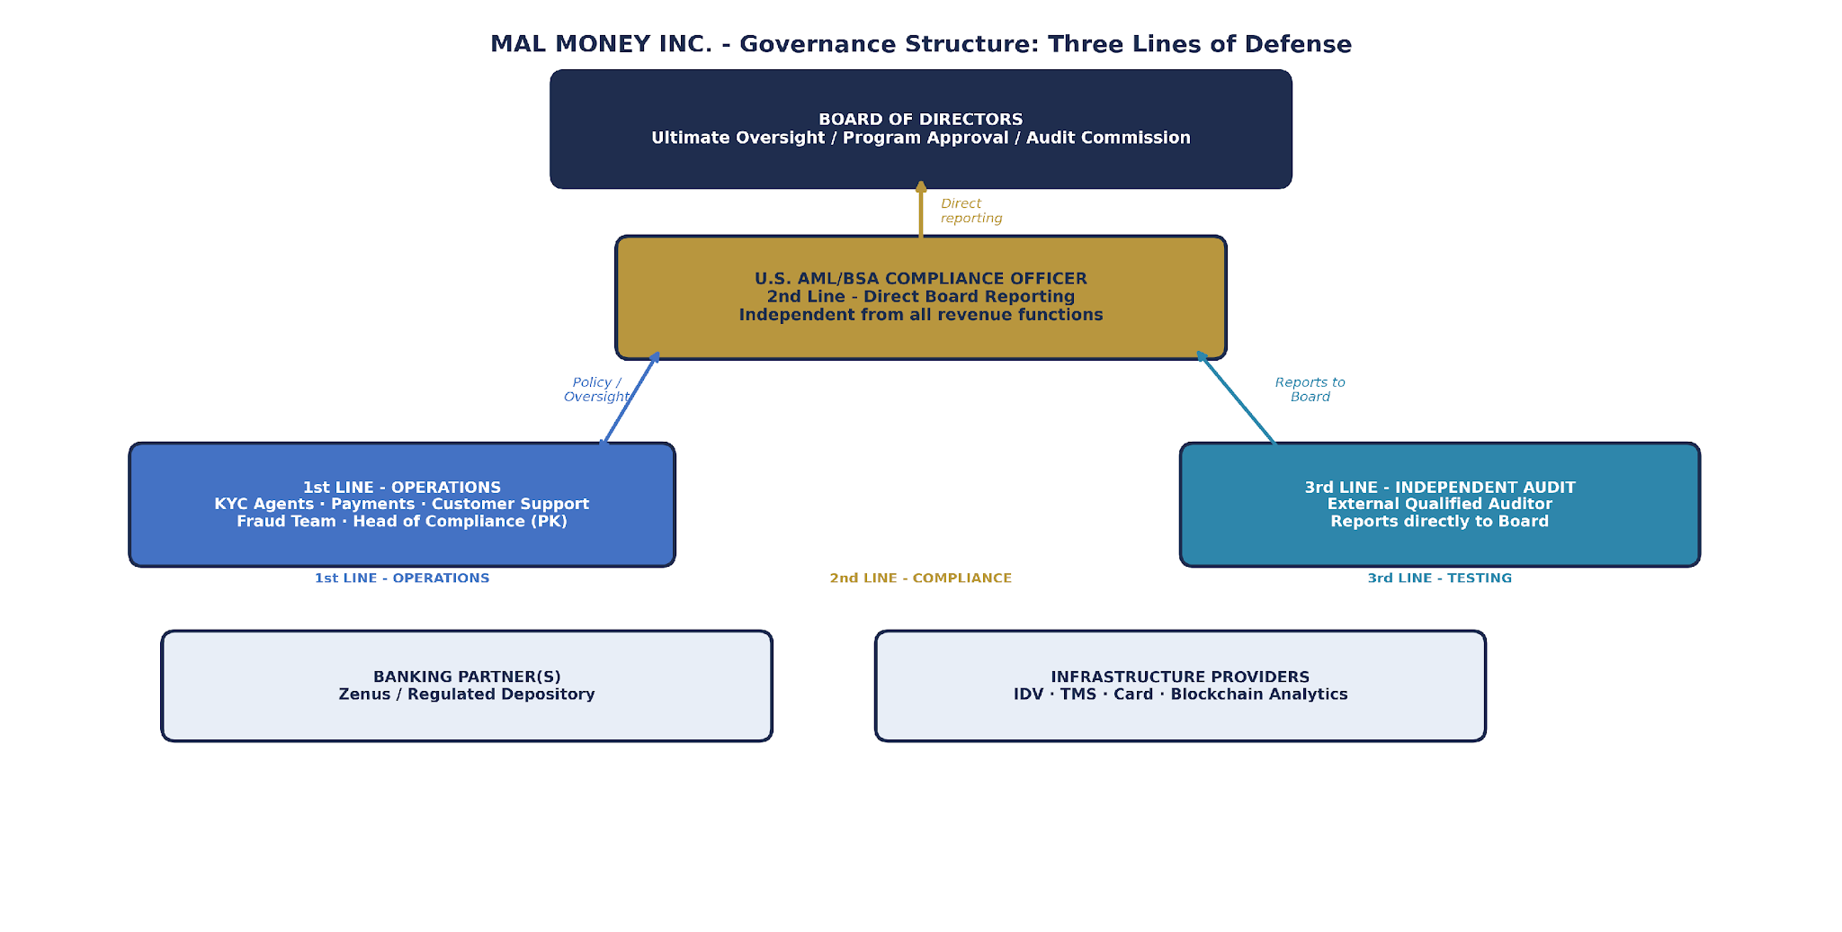
Figure 3 - Three Lines of Defense. The U.S. AML/BSA CO holds a direct, independent reporting line to the Board. The Head of Compliance (Pakistan) operates within the first-line coordination role. Banking Partners and Infrastructure Providers are external to the three-line structure.

6. Enterprise Risk Assessment - Risk-to-Control Linkage
The Company's enterprise risk assessment provides the analytical foundation for every control decision in this Program. Controls that are not demonstrably linked to identified risks are difficult to justify, expensive to maintain, and unlikely to be effective. Conversely, identified risks for which no control has been designed represent unaddressed compliance exposure.
The Risk-to-Control Matrix (Annex 2) documents this linkage for each identified risk category, specifying the relevant control, its governing document, its owner, its review frequency, and the evidence that demonstrates it is operating effectively. The risk assessment is updated at least annually and upon any new corridor, product, partner change, or material regulatory development.

7. Corridor Risk Classification Framework
Corridor | Company Risk | FATF (Feb 2026) | Primary Internal Risk Basis
Pakistan | VERY HIGH | NOT on grey list (removed Oct 2022) | TF risk; hawala/hundi prevalence; KPK/FATA/Balochistan province risks; weak institutional controls in high-risk regions
Bangladesh | HIGH | NOT on grey list | Trade-based ML; NPO/charity TF exposure; weak AML enforcement; remittance vulnerability
Egypt | HIGH | NOT on grey list | Currency control evasion; informal economy; limited AML enforcement; regional sanctions proximity
Turkey (Turkiye) | MEDIUM-HIGH | NOT on grey list (removed June 2024) | Geographic position; gold/CVC trading risks; historical ML typologies; residual risk post-FATF removal
UAE | MEDIUM-HIGH | NOT on grey list (removed Feb 2024) | Trade finance ML; real estate risk; high-value cash economy; proximity to sanctioned jurisdictions

No new corridor may go live without a completed Corridor Addendum (Annex 10) signed by the CO. High or Very High Risk corridors require Board approval before go-live. Each active Corridor Addendum is revalidated annually. Corridor risk classifications are reviewed concurrently with the annual enterprise risk assessment.

8. Customer Risk Management
Customer risk management is the starting point for every downstream compliance decision in this Program. The quality of the Company's onboarding, due diligence, and periodic refresh processes determines the accuracy of its risk model, the reliability of its monitoring outputs, and the defensibility of its SAR and OFAC decisions.
The Company's risk-based approach means that not every customer is treated identically. Instead, the Company calibrates its verification requirements, ongoing monitoring intensity, and review frequency to the actual risk profile of each customer relationship - assessed against both customer-specific risk factors and the risk profile of the corridor in which the customer operates. This calibration is not optional. It is the operating methodology that gives the program its legal and operational integrity.
These procedures are designed as a risk-based KYC/CDD framework consistent with U.S. AML expectations, applicable FinCEN guidance, and Banking Partner requirements. They are not claimed as direct implementation of the bank CIP rule (31 C.F.R. § 1020.220), which applies to covered financial institutions as a matter of their own primary regulatory obligations. Full tiered procedures are set out in Annex 3.

8.1 Beneficial Ownership
Tier 1/2: 25% ownership threshold plus one control person per 31 C.F.R. § 1010.230. Tier 3 EDD: internal enhanced standard of 10% - a more stringent internal requirement, not a separate statutory threshold. The 10% standard provides additional depth for the Company's highest-risk relationships where reliance on the statutory minimum would be insufficient given the risk profile.

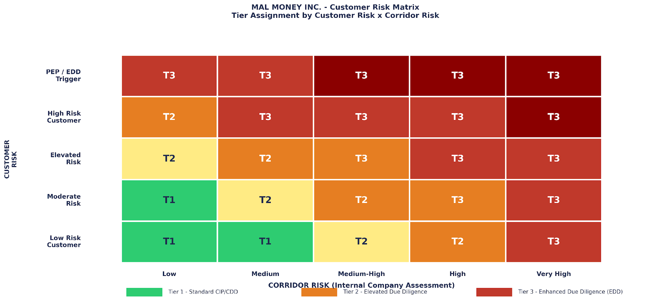
Figure 4 - Customer Risk Matrix. Tier assignment reflects the intersection of customer-specific risk factors and the Company's internal corridor risk classification. All five active corridors are classified Medium-High or above under the Company's internal framework.

9. Transaction Monitoring and SAR Governance
Transaction monitoring is the operational mechanism through which the Company detects suspicious activity that does not reveal itself through static customer data alone. Many of the most significant ML and TF risks only become visible through patterns of transactional behavior - not through any single transaction or individual piece of customer information taken in isolation.
The Company's TM program is designed around the specific risk profile of its customer base, corridor mix, and asset classes. It is not a generic threshold-monitoring system. It incorporates corridor-specific typologies, asset class-specific detection rules, and real-time integration of FinCEN advisory updates to ensure that detection capability remains calibrated to current and emerging financial crime risks.

9.1 Monitoring Coverage
The TM program covers: ACH return/recall abuse; corridor-linked ML typologies; CVC kiosk-linked fraud (FIN-2025-CVCKIOSK, August 4, 2025); Chinese ML network typologies (FIN-2025-A003, August 28, 2025); stablecoin/CVC layering patterns; hawala and informal value transfer indicators; enhanced sanctions and illicit finance indicators. Full operational detail in Annex 4.

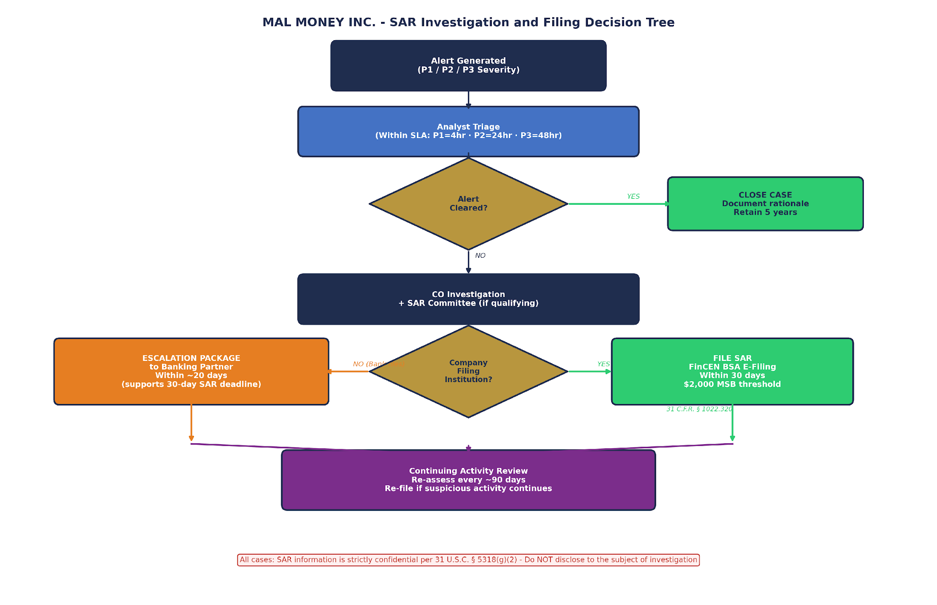
Figure 5 - SAR Investigation and Filing Decision Tree. All alerts flow through analyst triage (SLA: P1=4hr, P2=24hr, P3=48hr). CO investigation and SAR Committee review precede filing or escalation. 30-day deadline applies where Company is filer; ~20-day escalation package deadline applies where Banking Partner files.

9.2 Alert Severity Model
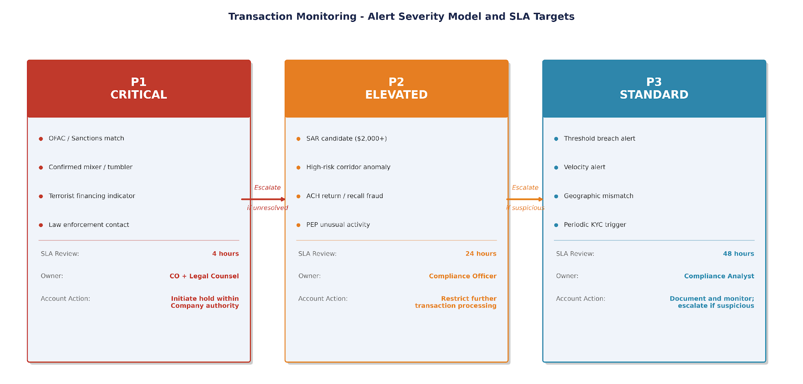
Figure 6 - Alert Severity Model. P1 Critical alerts (OFAC match, mixer exposure, TF indicator) require 4-hour CO response. P2 Elevated alerts (SAR candidates, ACH fraud) require 24-hour CO response. P3 Standard alerts (threshold breaches, velocity anomalies) require 48-hour analyst response.

9.3 KYC/CDD Tier Assignment
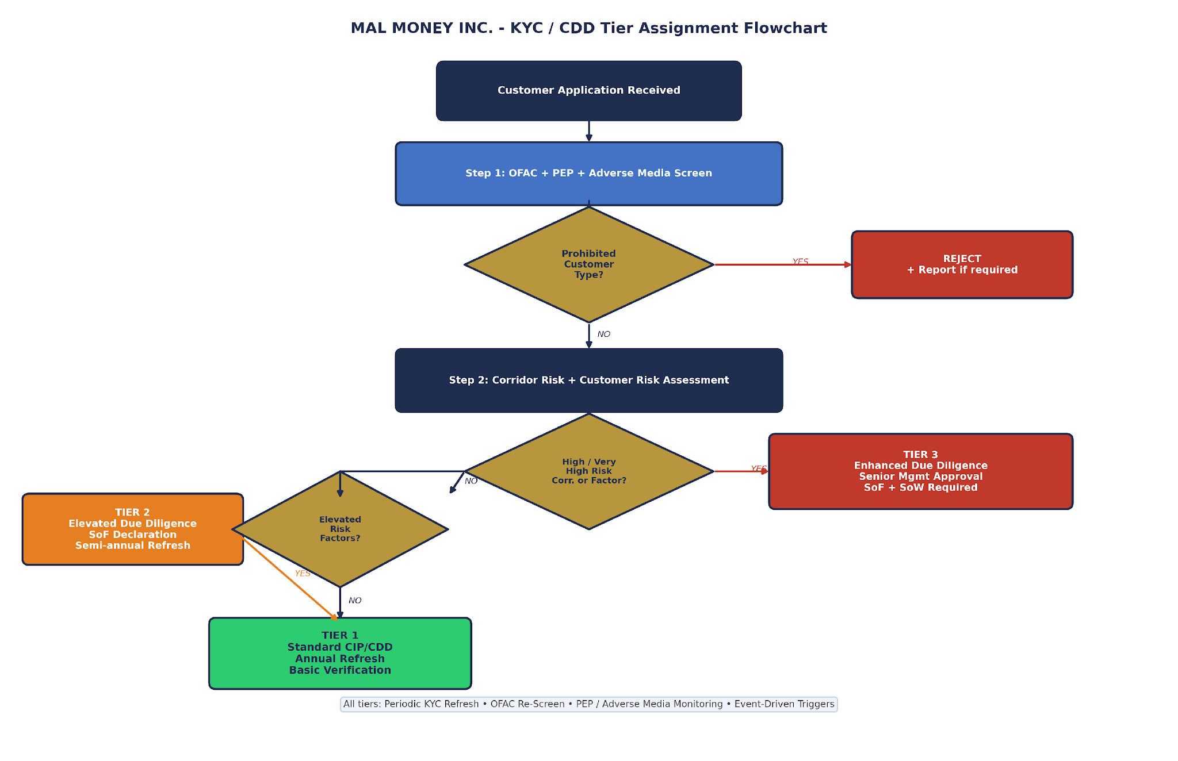
Figure 7 - KYC/CDD Tier Assignment Flowchart. All customers are subject to OFAC, PEP, and adverse media screening as a threshold step. Corridor risk classification and customer-specific risk factors jointly determine tier assignment. Prohibited customer types trigger immediate rejection.

9.4 Pakistan Province Sub-Risk Classification
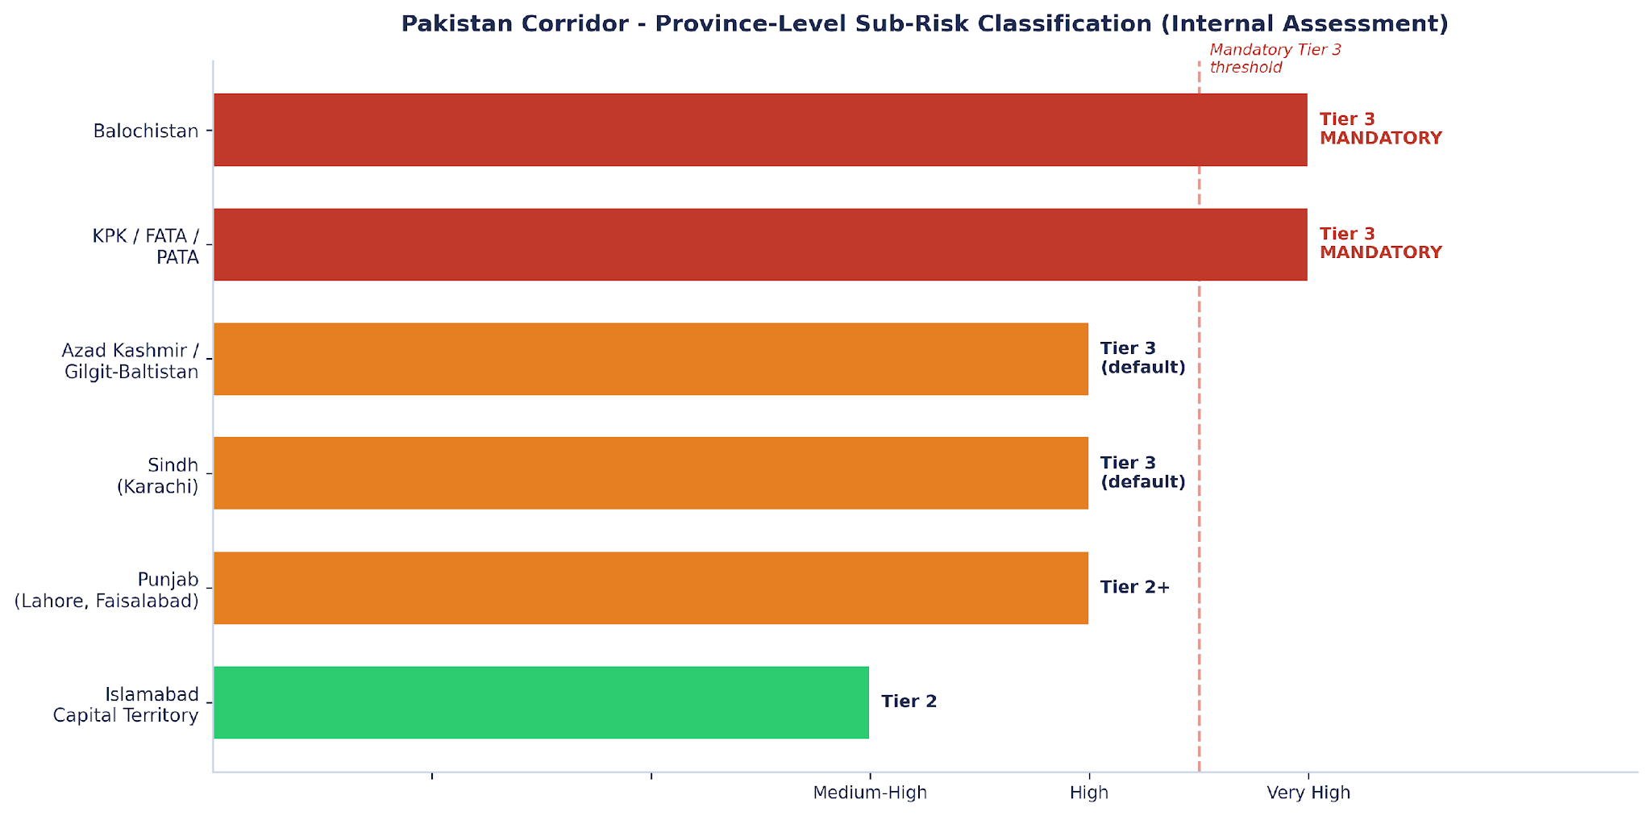
Figure 8 - Pakistan Province-Level Sub-Risk Classification (internal assessment). KPK/FATA/PATA and Balochistan: Tier 3 mandatory. Sindh (Karachi) and Azad Kashmir: Tier 3 default. Punjab: Tier 2+ with reduced thresholds. Islamabad Capital Territory: Tier 2 standard.

9.5 Enhanced Sanctions and Illicit Finance Screening
In addition to primary OFAC SDN screening, all transactions and counterparties are subject to enhanced sanctions and illicit finance screening covering: SDGT; SDNTK; NPWMD; E.O. 13224 and E.O. 13268; country-specific OFAC programs; UN Security Council Consolidated List. OFAC digital asset wallet screening is applied via blockchain analytics for virtual asset transactions.

9.6 SAR Committee and Quality Assurance
For qualifying SAR cases, the SAR Committee - comprising the CO and a designated senior management representative - reviews the investigation file, the proposed SAR narrative, and the legal basis for filing. Pre-filing quality assurance is conducted by the CO on all SAR packages. Post-filing review is used to refine detection rules. Quarterly SAR trend analysis is provided to the Board.

10. Sanctions Compliance
Sanctions compliance is structurally distinct from AML/BSA reporting. AML/BSA reporting is retrospective - it responds to suspicious activity that has been detected after the fact. Sanctions compliance is prospective and preventive - it is designed to stop prohibited transactions from occurring at all and to prevent any property of sanctioned persons from being held, transferred, or made available without authorization.
The Company maintains a dedicated sanctions compliance infrastructure that operates in parallel with, and is integrated into, its AML/BSA program. A confirmed OFAC match is a P1 Critical alert that triggers immediate response protocols - not a routine investigation. The Company tracks all five components of OFAC's framework: management commitment; risk assessment; internal controls; testing and auditing; and training.
Annual Blocked Property Report (ARBP): filed with OFAC by September 30 for property held as blocked as of June 30 of the same year, per 31 C.F.R. § 501.603, where the Company is the responsible reporting party holding blocked property. Applicability is confirmed in the companion Governance and Legal Positioning Memorandum.

11. Independent Testing Commitment
The independent testing function is distinct from internal monitoring and quality assurance conducted by the Compliance Department. Its purpose is to assess whether the AML/BSA program is operating effectively as designed - including whether controls are commensurate with identified risks, whether monitoring rules are producing results, and whether the program has kept pace with changes in the business and regulatory environment.

12. Exceptions and Issues Management
Compliance exceptions and identified issues are not aberrations to be minimized or concealed - they are information. They indicate where the program is working, where it is not, and what resource or process changes are required. The Company's exception and issues management framework is designed to ensure that this information reaches the right decision-makers at the right time, with appropriate urgency and remediation accountability.

Severity | Definition | Remediation SLA | Board Reporting | Closure Criteria
CRITICAL | Regulatory breach or imminent violation | Same business day | CO + Board: immediately | Root cause resolved; Board notified; evidence on file
HIGH | Material control gap; potential unreported SAR | 5 business days | CO immediately; Board next meeting | Root cause resolved; Board notified
MEDIUM | Procedural gap; control not operating as designed | 30 days | CO tracked; Board quarterly dashboard | Remediated; CO sign-off
LOW | Minor inconsistency; training gap | 90 days | CO tracked; Board annual | Remediated; CO sign-off
EXCEPTION | Approved deviation (max 90 days) | Per approval | Board quarterly if ongoing | Resolved or formally renewed

See Annex 6 (Exceptions and Issues Register) and Annex 7 (Internal Escalation and Case Intake Form).

13. Board Compliance Dashboard and Metrics
The Board compliance dashboard is the primary instrument through which the Board of Directors exercises its ongoing oversight of the AML/BSA program between formal review cycles. It is not a ceremonial reporting document - it is the mechanism by which the Board identifies emerging risk concentrations, assesses program effectiveness, evaluates resource allocation, and fulfills its governance responsibilities under applicable law and regulatory guidance.
The CO delivers the quarterly dashboard and an annual Program Effectiveness Report. The annual report addresses: (i) whether controls remain commensurate with identified risks; (ii) typology library updates; (iii) monitoring tuning outcomes; (iv) training effectiveness; (v) independent testing outcomes; and (vi) recommended Program updates. The Board does not simply receive this report - it acts on it.

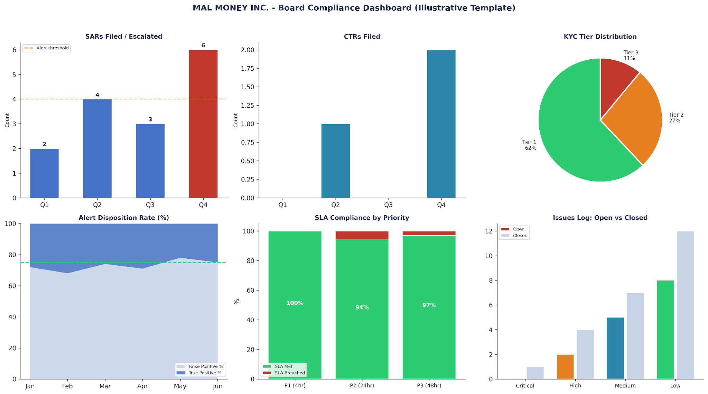
Figure 9 - Illustrative Board Compliance Dashboard. Delivered quarterly. Key metrics: SARs filed/escalated, CTR compliance, OFAC screening events, alert SLA performance by tier (P1/P2/P3), open issues by severity, KYC tier distribution, training completion rate, and independent audit status.

14. Change Management and Vendor Oversight
No AML/BSA program is static. New corridors introduce new risk profiles and potentially new regulatory obligations. New Banking Partners introduce new filing allocation and contractual compliance questions. New infrastructure providers introduce new operational dependencies and third-party risk exposures. New products or customer segments may trigger new obligations entirely.
The change management framework described in this Section is designed to ensure that the compliance program remains calibrated to the Company's actual operating model throughout the lifecycle of the business. Consistent with the 2023 interagency third-party risk guidance (OCC/FDIC/FRB, June 2023) and FDIC FIL-29-2023, the Company applies a full vendor oversight lifecycle: planning, due diligence, contract negotiation, ongoing monitoring, and termination.
- No new Banking Partner relationship is activated without documented vendor due diligence, compliance capability assessment, and Board notification or approval per the corridor risk level.
- No new corridor goes live without a completed Corridor Addendum (Annex 10) signed by the CO and approved by the Board (where High or Very High Risk).
- No new product or customer segment is launched without a compliance impact assessment reviewed by the CO.

15. Training
Training is the mechanism through which the Company ensures that the people responsible for implementing this Program understand what it requires, why it requires it, and what to do when they encounter something unexpected. A technically strong compliance program that is not understood by those who operate it is not an effective compliance program - and regulators assess both the written framework and its practical implementation.
The Company's training program is not a one-time event. It is a continuous process of baseline training, annual refresh, role-specific development, and real-time incorporation of new regulatory guidance. FinCEN advisories and notices are incorporated into the training curriculum within 30 days of material publication. Training records are maintained for 5 years and are producible to auditors and regulators upon request. Full training architecture is in Annex 8; attendance and evidence forms are in Annex 9.

16. Recordkeeping and Version Control
Recordkeeping is both a regulatory obligation and a practical operational necessity. Without accurate, complete, and timely records, the Company cannot demonstrate compliance to auditors, regulators, or Banking Partners on request. Without consistent version control, the Company cannot demonstrate that its Program has kept pace with its evolving business model and regulatory environment.
- All AML-required records retained minimum 5 years per 31 C.F.R. Chapter X. SAR supporting documentation: 5 years from filing date. SAR filings themselves: strictly confidential, maintained separately from general compliance files.
- Logbooks architecture: see Annex 13 (Logbooks Index) and the separate Logbooks Pack (FILE6, .xlsx). All 10 operational logs must be kept current and producible to auditors and regulators upon request.
- This Program is updated at least annually and upon any material change to the Company's business model, regulatory status, or corridor structure. All material updates are presented to the Board for approval before implementation. All prior versions are archived with the date of supersession.

ANNEX - 1 - BOARD RESOLUTION APPROVING AML/BSA COMPLIANCE FRAMEWORK

RESOLUTION OF THE BOARD OF DIRECTORS OF MAL MONEY INC.

WHEREAS the Company is committed to maintaining an effective AML/BSA compliance program; WHEREAS the Board has reviewed the AML/BSA Compliance Program and all companion documents in this Package; NOW, THEREFORE, BE IT RESOLVED:

- PROGRAM ADOPTION: The Board approves and adopts the AML/BSA Compliance Program dated March 31, 2026. All prior versions are superseded.
- COMPLIANCE OFFICER: [NAME OF COMPLIANCE OFFICER - to be inserted upon execution] is confirmed as the AML/BSA Compliance Officer with full authority to implement and enforce this Program. The CO has direct functional reporting access to the Board. CO compensation is not tied to revenue or profit metrics. CO removal requires Board resolution.
- GOVERNANCE: The Board confirms the three lines of defense structure; CO independence from revenue functions; and CO authority to escalate directly to the Board on any compliance matter without management approval.
- INDEPENDENT TESTING: The Company commits that the Program will be subject to independent testing within twelve (12) months of the Company's commercial launch date, and thereafter on a risk-based schedule. The tester shall not be the CO. The Board shall receive the testing report directly.
- QUARTERLY REPORTING: The Board requires a quarterly compliance dashboard per Annex 12 and an annual Program Effectiveness Report.
- CORRIDOR GOVERNANCE: No new High or Very High Risk corridor may go live without Board approval. No Medium-High Risk corridor may go live without CO sign-off and Board notification within 30 days.
- RESOURCES: Management is directed to ensure the CO has adequate staffing, budget, and technology to fulfill all program obligations.

_____________________________ _____________________________ _____________________________
Chairperson of the Board Director Board Secretary

Adopted as of the date of the last authorized signature below

ANNEX - 2 - RISK-TO-CONTROL MATRIX

This Matrix documents the demonstrable linkage between each identified AML/BSA risk and its governing control. The integrity of this linkage - showing that every material risk has an assigned control, owner, review schedule, and evidence standard - is one of the key indicators regulators and auditors use to assess program effectiveness. Updated at each annual risk assessment and upon material change.

Customer and Identity Risk
Specific Risk | Level | Control | Document | Owner | Review | Evidence
False identity at onboarding | HIGH | Document + non-document ID verification; biometric; database check | Annex 3 - KYC | KYC Agent + CO | Per onboarding | KYC file; IDV logs; verification records
Beneficial owner concealment | HIGH | BO declaration: 25% (T1/2) or 10% (T3); verification of each identified BO | Annex 3 s.A3.4 | CO | Per onboarding + refresh | BO declaration; verification records; source documentation
PEP status not identified | HIGH | PEP database at onboarding and each KYC refresh cycle | Annex 3 s.A3.1 | Analyst / CO | Per onboarding + refresh | PEP screening log; adjudication records
Prohibited customer type accepted | VERY HIGH | Pre-onboarding prohibited customer check; OFAC screen; CO sign-off for T3 | Annex 3 s.A3.5 | CO | Per onboarding | Onboarding approval; screening output; rejection records
Customer activity deviates from stated profile | HIGH | Periodic KYC refresh (T1 annual; T2 semi-annual; T3 quarterly); event-driven triggers | Annex 3 s.A3.6 | CO | Per tier cadence | KYC refresh log; event trigger documentation

Transaction Monitoring and Sanctions Risk
Specific Risk | Level | Control | Document | Owner | Review | Evidence
Structuring / smurfing | HIGH | Sub-threshold aggregation rule; velocity monitoring; cash-pattern alerts | Annex 4 - TM | CO / Analyst | Continuous | Alert log; investigation records; disposition documentation
ACH recall / return fraud | HIGH | R10/R29 P2 trigger; CO recall queue; 0.5% return rate threshold; weekly monitoring | Annex 4 s.A4.3 | CO | Continuous + weekly | ACH recall log; return rate reports
Stablecoin layering via mixer/tumbler | VERY HIGH | Blockchain analytics; exposure above configured threshold = P1 hold; CO investigation | Annex 4 s.A4.4 | CO | Continuous | Blockchain analytics report; P1 alert log; investigation file
SDN-listed person onboarded or transacting | VERY HIGH | Real-time OFAC SDN; fuzzy matching; re-screening at each KYC refresh | s.10; Annex 3 | CO / System | Continuous | Screening log; adjudication records; OFAC correspondence
OFAC report not filed within deadline | HIGH | P1 immediate escalation; OFAC reporting calendar; ARBP cycle (June 30 snapshot / September 30 filing) | Annex 5; s.10 | CO | Per event; annually | OFAC report copy; filing date confirmation; correspondence
Independent audit not conducted | HIGH | 12-month commitment in Annex 1 Board Resolution; Board oversight; CO coordination responsibility | Annex 1; s.11 | CO + Board | Within 12 months of launch | Board Resolution; engagement letter; audit report

ANNEX - 3 - KYC / CUSTOMER IDENTIFICATION AND DUE DILIGENCE PROCEDURES

Version | 1.0
Effective Date | March 31, 2026
CIP Basis | Risk-based KYC/CDD framework consistent with U.S. AML expectations and Banking Partner requirements - not claimed as direct implementation of 31 C.F.R. § 1020.220 (the bank CIP rule)
Cross-Reference | AML/BSA Program s.8 | Annex 2 Risk-to-Control Matrix | Annex 5 Filing Allocation Matrix

A3.1 Risk-Tiered Onboarding Framework

Tier 1 - Standard Customer Identification
Required at minimum: full legal name; date of birth or incorporation date; physical address (not P.O. Box only); government-issued ID number; OFAC, PEP, and adverse media screening. Account activity consistent with stated purpose verified through transactional monitoring. Review cycle: annual.

Tier 2 - Elevated Due Diligence
Additional to Tier 1: source of funds declaration with supporting documentation; enhanced business purpose verification; third-party database corroboration; CO notification within 24 hours of activation. Review cycle: semi-annual; event-driven triggers between cycles.

Tier 3 - Enhanced Due Diligence (EDD)
Additional to Tier 2: comprehensive source of funds and source of wealth documentation with independent corroboration; detailed business purpose and expected transaction profile; independent background investigation; Senior Management written approval before activation; quarterly refresh plus monthly transactional monitoring review.

A3.2 Corridor Risk Classification

Corridor | Company Risk | FATF (Feb 2026) | Default Tier
Pakistan | VERY HIGH | Not on grey list | Min. Tier 2; Tier 3 mandatory for province triggers
Bangladesh | HIGH | Not on grey list | Min. Tier 2; Tier 3 for elevated factors
Egypt | HIGH | Not on grey list | Min. Tier 2; Tier 3 for elevated factors
Turkey (Turkiye) | MEDIUM-HIGH | Not on grey list (removed June 2024) | Tier 2 default; Tier 3 where elevated factors
UAE | MEDIUM-HIGH | Not on grey list (removed Feb 2024) | Tier 2 default; Tier 3 where elevated factors

A3.3 Pakistan Province-Level Sub-Risk
Province / Region | Sub-Risk Level | EDD Controls
Islamabad Capital Territory | MEDIUM-HIGH | Standard Tier 2 + volume monitoring; geographic review upon threshold breach
Punjab (Lahore, Faisalabad) | HIGH | Transaction thresholds 30% lower than standard; enhanced SoF documentation above corridor threshold
Sindh (Karachi) | HIGH | Tier 3 default; Senior Management approval required; monthly CO review of all active accounts
Azad Kashmir / Gilgit-Baltistan | HIGH | Tier 3 default; cross-border flow monitoring; NPO/charity connection = automatic EDD trigger
KPK / FATA / PATA | VERY HIGH | Tier 3 MANDATORY; TF screening enhanced; CO pre-approval required per individual customer onboarding; NPO connections = automatic EDD
Balochistan | VERY HIGH | Tier 3 MANDATORY; prior CO approval required per onboarding; monthly CO review of all active accounts in this province

A3.4 Beneficial Ownership
- Tier 1 and Tier 2: 25% ownership threshold plus one control person per 31 C.F.R. § 1010.230. Both prongs apply independently.
- Tier 3 EDD: internal enhanced standard of 10% identification and verification - more stringent than the regulatory minimum, not a separate statutory threshold. Provides additional depth for highest-risk relationships.

A3.5 Prohibited Customer Types
- OFAC SDN-listed persons or entities 50%+ owned by SDNs.
- Shell banks; unregistered or unlicensed MSBs; anonymous accounts; fictitious identities.
- Confirmed adverse media: ML, TF, trafficking, narcotics, sanctions evasion.
- Cryptocurrency mixing/tumbling providers; cannabis-related businesses (federal law conflict).
- Any entity expressly prohibited by the Company's Banking Partner relationships.

ANNEX - 4 - TRANSACTION MONITORING PROCEDURES

Version | 1.0
Effective Date | March 31, 2026
Key References | FIN-2025-CVCKIOSK (Aug 4, 2025) | FIN-2025-A003 (Aug 28, 2025) | FATF Rec. 16
Cross-Reference | AML/BSA Program s.9 | Annex 2 Risk-to-Control Matrix | Annex 5 Filing Allocation Matrix

A4.1 Alert Severity Model
Priority | Definition | Trigger Examples | SLA / Owner | Company Action
P1 CRITICAL | Immediate risk of regulatory violation or financial crime | OFAC match; mixer/tumbler exposure above threshold; confirmed TF indicator; law enforcement contact | 4 hours / CO + Legal | Initiate account hold within Company authority; escalate to Banking Partner; document all steps taken
P2 ELEVATED | Likely suspicious activity at SAR/escalation threshold | SAR candidate ($2,000+); PEP anomaly; ACH recall fraud; high-risk corridor activity spike | 24 hours / CO | Restrict further transaction processing within Company authority; initiate full CO investigation
P3 STANDARD | Alert requiring review; may be explainable by known customer activity | Threshold breach; velocity alert; geographic mismatch; KYC periodic trigger | 48 hours / Analyst | Document; review; escalate to P2 if suspicious; no account restriction unless escalated

A4.2 SAR Filing and Escalation

Where Company is Filing Institution
SAR filed within 30 days at $2,000 MSB threshold per 31 C.F.R. § 1022.320. SAR Committee review for qualifying cases. Pre-filing quality assurance by CO. Continuing activity SARs on ~90-day cycle while suspicious activity continues. SAR contents strictly confidential per 31 U.S.C. § 5318(g)(2) - not disclosed to subject.

Where Banking Partner is Filing Institution
Company prepares complete escalation package within ~20 days of initial detection, supporting the Banking Partner's 30-day filing deadline. Package includes: investigation narrative; transaction records; customer identification; supporting evidence. All escalations logged with transmission timestamp, partner acknowledgment, and outcome tracking.

A4.3 ACH Return and Recall Fraud Controls
- R10/R29 returns: P2 alert immediately; restrict further outbound ACH transactions within Company authority pending CO review.
- ACH recall requests: all routed to CO queue for manual review before any recall is processed.
- Return rate: weekly monitoring. Rate above 0.5% unauthorized returns triggers mandatory investigation and root-cause report to Board within 15 days.

A4.4 Stablecoin and CVC Monitoring
Mixer/tumbler exposure above configured blockchain analytics threshold: P1 alert and account hold within Company authority (threshold-based rule, not zero-exposure absolute). All virtual currency typologies from FIN-2025-CVCKIOSK (August 4, 2025) and Chinese cross-border ML networks from FIN-2025-A003 (August 28, 2025) are incorporated as monitoring scenarios. OFAC digital asset wallet screening applied to all virtual asset transactions via blockchain analytics.

ANNEX - 5 - REGULATORY REPORTING AND FILING ALLOCATION MATRIX

Event | Detects | Investigates | Decides | Files / Escalates | Deadline | Evidence Retained
SAR ($2,000+) | Company TM | Company CO | CO + SAR Committee | Filed or escalated in accordance with the confirmed filing allocation reflected in the Governance, Regulatory Perimeter and Compliance Positioning Memorandum. | 30 days | SAR copy or escalation log; 5-yr - CONFIDENTIAL
CTR ($10,000+) | System | CO / BP | Filed or escalated in accordance with the confirmed filing allocation reflected in the Governance, Regulatory Perimeter and Compliance Positioning Memorandum. | Filed or escalated in accordance with the confirmed filing allocation reflected in the Governance, Regulatory Perimeter and Compliance Positioning Memorandum. | 15 calendar days | CTR copy; transaction records; 5-yr
OFAC Blocking | Sanctions system | CO | CO | Filed or escalated in accordance with the confirmed filing allocation reflected in the Governance, Regulatory Perimeter and Compliance Positioning Memorandum. | 10 business days | Blocking report; escalation log
OFAC Rejection | Sanctions system | CO | CO | Filed or escalated in accordance with the confirmed filing allocation reflected in the Governance, Regulatory Perimeter and Compliance Positioning Memorandum. | 10 business days | Rejection report; transaction records
ARBP | CO | CO | CO | Filed or escalated in accordance with the confirmed filing allocation reflected in the Governance, Regulatory Perimeter and Compliance Positioning Memorandum. | September 30 | Annual report copy; blocked property inventory
314(a) Request | CO | CO | CO | Company to FinCEN (positive matches only) | ~2 weeks from request | 314(a) log - STRICTLY CONFIDENTIAL
314(b) Sharing | CO | CO | CO | Verified counterpart (FinCEN notice first) | Per procedures | Sharing log; FinCEN notice on file
Travel Rule ($3,000+) | System | N/A | CO | Company retains; transmits to receiving VASP | At transmittal | Originator + beneficiary info; 5-yr
Law enforcement | CO | CO + Legal | CO + Legal | Company to requesting authority | Per the order | Copy of order; response log; Legal confirmation
Partner escalation | Company TM | CO | CO | Company to Banking Partner (package) | ~20 days from detection | Escalation package; transmission record; partner ack.

Annual Compliance Deadlines - Quick Reference
Timing | Obligation | Owner
Within 15 days | CTR filing for each qualifying cash transaction | CO / BP Filed or escalated in accordance with the confirmed filing allocation reflected in the Governance, Regulatory Perimeter and Compliance Positioning Memorandum.
Within 30 days | SAR filing from initial detection (where Company is filer) | CO
Within 10 bus. days | OFAC blocking / rejection report | CO (per confirmed scope)
September 30 | ARBP for property held as of June 30 | CO (where applicable)
Quarterly | Board compliance dashboard delivered | CO
Annually | Enterprise-wide AML risk assessment updated; all Corridor Addenda revalidated; Program reviewed | CO + Board
Within 12 months of launch | Independent AML audit conducted | CO coordinates; Board receives

ANNEX - 6 - EXCEPTIONS AND ISSUES REGISTER

Live register tracking all compliance exceptions from identification through closure. Updated by the CO and reported to the Board quarterly. This register is not a confidential document - it is the operational evidence of the Company's issues identification and remediation capability.

Severity | Definition | Remediation SLA | Board Reporting | Closure Criteria
CRITICAL | Regulatory breach or imminent violation | Same business day | CO + Board: immediately | Root cause resolved; Board notified; evidence on file
HIGH | Material control gap; potential unreported SAR | 5 business days | CO immediately; Board next meeting | Root cause resolved; Board notified
MEDIUM | Procedural gap; control not operating as designed | 30 days | CO tracked; Board quarterly dashboard | Remediated; CO sign-off
LOW | Minor inconsistency; training gap | 90 days | CO tracked; Board annual | Remediated; CO sign-off
EXCEPTION | Approved deviation (max 90 days) | Per approval | Board quarterly if ongoing | Resolved or formally renewed

Active Issues Register
Issue ID | Source / Description | Sev. | Owner | Target Date | Status / Notes
ISS-001 | [Describe issue or exception] | [S] | [Name/Role] | March 31, 2026 | [Open / In Progress / Closed - describe action taken]
ISS-002 | [Add rows as needed] | [ ] | [ ] | [ ] | [ ]

ANNEX - 7 - INTERNAL ESCALATION AND CASE INTAKE FORM

Section 1 - Case Identification
Case ID (system-assigned) | [Complete at intake]
Date and Time of Intake
Intake completed by (Name / Role)
Case Type | Suspicious Activity  Sanctions/OFAC  ACH/Fraud  Adverse Media/PEP  Partner Escalation  KYC/Offboarding  Other
Priority Level | P1 - Critical (4-hour CO review SLA) P2 - Elevated (24-hour CO) P3 - Standard (48-hour analyst)
Customer name / entity
Customer ID (internal)
KYC Tier at time of escalation | [Tier 1 / Tier 2 / Tier 3]
Corridor(s) involved
Transaction amount(s) (USD equiv.)
Summary of suspicious activity | [REQUIRED: who, what, when, where, why suspicious - minimum 3 sentences]
Red flags identified
Alert rule(s) that triggered (if automated)

Section 2 - CO Review and Disposition
CO Review Date and Time
CO Name
Disposition | SAR - file direct / SAR to Banking Partner / CTR triggered / OFAC action / No SAR (rationale documented) / Account restriction / Termination / Further investigation
CO rationale (minimum 4 sentences)
Date of SAR filing or escalation transmission
Deadline met? | [Yes / No - if No, explain and document Board notification]
Date case closed

ANNEX - 8 - TRAINING PROGRAM

The training program is the mechanism through which the Company ensures operational understanding of this Program across all relevant personnel. Training completion is tracked in the Training Attendance Log (Logbooks Pack, FILE6). 100% completion of annual refresh training is required by December 31 of each calendar year.

Role | New Hire | Annual Refresh | Specialized | Board/Mgmt
AML/BSA Compliance Officer | Within 30 days | Annual | External CO training; FinCEN advisory update | Annual Board briefing
Compliance Analysts / Investigators | Within 30 days | Annual | SAR narrative; blockchain analytics; corridor typologies | N/A
KYC Agents / Onboarding Specialists | Within 30 days | Annual | Corridor EDD; document verification; BO | N/A
Operations / Payments Staff | Within 30 days | Annual | ACH fraud awareness; OFAC screening; Travel Rule | N/A
Board of Directors | N/A | Annual | N/A | Annual AML overview; audit findings; metrics

Training Delivery Requirements
Training Type | Schedule / Trigger | Key Requirements
New hire - all role-applicable modules | Within 30 days of start; before compliance-relevant duties | Test score >=80%; attestation signed; logged in Training Attendance Log
Annual refresh - all staff | Calendar year; 100% by December 31 | Records retained 5 years; results reported in annual Program Effectiveness Report
FinCEN advisory/notice update | Within 30 days of material FinCEN publication | CO + compliance analysts minimum; tracking in Training Attendance Log
Incident-driven training | Following material compliance incident or audit finding | Targeted to affected roles; records document remediation
Board annual briefing | At first Board meeting after year-end | Board minutes document attendance, topics, and any Board determinations made

ANNEX - 9 - TRAINING PROTOCOL - ATTENDANCE AND EVIDENCE FORM

Complete one Protocol per training session. Retain minimum 5 years. Also log each session in the Training Attendance Log (Logbooks Pack, FILE6). This Protocol is evidence that the training obligation was fulfilled and the content was delivered.

Training Session Title / Module(s)
Date of Session
Session Duration
Location / Platform
Trainer / Facilitator Name and Role
Training Type | New Hire / Annual Refresh / Role-Specific / Incident-Driven / FinCEN Update / Corridor-Specific / Board Briefing
Assessment Method | Online test (min. 80%) / Discussion and Q&A / Case study / Attendance only
Average Test Score (% if tested)

Attendee Sign-In
Full Name | Role / Department | Attended (v) | Signature / Initials

___________________________  Trainer / Facilitator - Signature / Date | ___________________________  CO Review / Countersignature / Date

ANNEX - 10 - CORRIDOR ADDENDUM

Part A - Corridor Identification and Source Log
Corridor Name / Country
ISO Country Code
Direction (send / receive / both)
Asset classes used
Payment rails
Estimated monthly volume (USD equiv.)
Estimated average transaction size
VASP / banking partner in corridor
Partner regulatory registration (local)
Corridor go-live target date
Next revalidation date (12 months from go-live)
Sources used for risk assessment

Part B - Risk Summary
Risk Factor | Assessment | Source / Date Checked
FATF public list status (data point only - not operative trigger) | [ ] | [Source - date: ___]
Corruption Index (TI CPI) | [ ] | [Source - date: ___]
TF-linked typologies in corridor | [ ] | [Source - date: ___]
Informal value transfer prevalence | [ ] | [Source - date: ___]
OFAC country-specific sanctions exposure | [ ] | [Source - date: ___]
Company internal risk classification | [ ] | [Source - date: ___]

Part C - Go-Live Checklist
 | Requirement | Status
___ | Parts A-B completed; source log date-checked | CO: ___ / Date: ___
___ | KYC/CIP adjustments configured and tested | CO: ___ / Date: ___
___ | TM monitoring rules updated and tested | CO: ___ / Date: ___
___ | Staff trained on corridor typologies | CO: ___ / Date: ___
___ | VASP partner compliance documentation received | CO: ___ / Date: ___
___ | Board notification (Medium-High corridors) | Board: ___ / Date: ___
___ | Board approval (High / Very High Risk corridors) | Board: ___ / Date: ___

ANNEX 11 - PAKISTAN CORRIDOR ADDENDUM - WORKING TEMPLATE FOR CORRIDOR FINALIZATION

Corridor | Pakistan (Islamic Republic of Pakistan)
ISO Code | PK
Direction | Outbound payout (send to PKR beneficiary bank accounts)
Asset classes | USDT, USDC (stablecoin off-ramp to PKR fiat)
Payment rails | Stablecoin to compliant VASP to PKR bank account via IBFT / RTGS
Estimated monthly volume | Client to confirm: approximate USD volume per month
VASP / banking partner in corridor | Client to confirm: name of local off-ramp / VASP partner(s)
Company Risk Classification | VERY HIGH - internal classification; NOT on FATF grey list (removed October 2022)
Next revalidation date | 12 months from go-live date

ANNEX 12 - ILLUSTRATIVE BOARD COMPLIANCE DASHBOARD - KPI/KRI TEMPLATE

Complete all fields with actual data before each Board meeting. This dashboard is the primary tool through which the Board exercises oversight of the AML/BSA program. Do not include SAR-specific identifying information (subject names, account details) in the Board report.

Metric / KPI-KRI | This Quarter | Prior Quarter | Threshold / Alert Level
SARs filed (direct) / escalated to Banking Partner | [ ] / [ ] | [ ] / [ ] | File / escalate all qualifying
CTRs filed / escalated | [ ] / [ ] | [ ] / [ ] | File all qualifying
OFAC screening true-match events | [ ] | [ ] | 0 - any match triggers immediate escalation
P1 Alerts - total / SLA met (%) | [ ] / [ ]% | [ ] / [ ]% | 100% SLA compliance target
P2 Alerts - total / SLA met (%) | [ ] / [ ]% | [ ] / [ ]% | 95% SLA compliance target
P3 Alerts - total / SLA met (%) | [ ] / [ ]% | [ ] / [ ]% | 90% SLA compliance target
Critical Issues - open / closed | [ ] / [ ] | [ ] / [ ] | 0 open Critical at any time
High Issues - open / closed | [ ] / [ ] | [ ] / [ ] | Alert if any open > 5 business days
Staff training completion rate | [ ]% | [ ]% | 100% by December 31 each year
Independent audit - status / date | [ ] | [ ] | Within 12 months of commercial launch
Active corridors / new this quarter | [ ] / [ ] | [ ] / [ ] | Each new corridor must have signed Addendum

ANNEX - 13 - LOGBOOKS INDEX AND EVIDENCE REGISTER

The Logbooks Pack (FILE6, separate .xlsx workbook) constitutes the operational evidence layer of this Program. It contains 10 operational logs covering the full lifecycle of AML/BSA compliance activities from alert detection through case closure, training completion, and audit findings remediation. All logs must be maintained as live documents and producible to auditors and regulators upon request without prior notice.

Log Name | Purpose | Maintained By | Retention
SAR-Escalation Log | Tracks all SAR filings and Banking Partner escalation packages from detection through filing/transmission | CO / Compliance Analyst | 5 years - CONFIDENTIAL
Alert-Investigation Log | Tracks all TM alerts from generation through triage, investigation, and disposition | CO / Compliance Analyst | 5 years
OFAC-Sanctions Log | Tracks all sanctions screening events, match adjudications, blocking/rejection actions, and OFAC reporting | CO / System | 5 years from action date
KYC Refresh Log | Tracks periodic and event-driven KYC refresh cycles for all active customers by tier | KYC Agent / CO | 5 years from account closure
314(a)/LE Requests Log | Tracks all FinCEN 314(a) requests and law enforcement inquiries - STRICTLY CONFIDENTIAL | CO | 5 years - CONFIDENTIAL
EDD Approval Log | Tracks all Tier 3 EDD initiations, documentation collected, and Senior Management approvals | CO | 5 years from account closure
Restriction-Offboarding Log | Tracks all account restrictions, suspensions, and terminations; confirms pre-termination SAR review | CO / Operations | 5 years from closure
Audit Findings Log | Tracks all audit and testing findings, remediation actions, Board reporting, and closure dates | CO | 5 years
Training Attendance Log | Tracks all AML/BSA training completion by employee; test scores; attestations | CO | 5 years from training date
Partner Escalation Tracking | Tracks all escalations to Banking Partners; transmission dates; partner acknowledgments; filing outcomes | CO | 5 years

